Technical Proposal
Custom Invoice Printing Chrome Extension
Prepared by: Riseup Labs
Date: April 29, 2026

Table of Contents
1. Executive Summary 3
2. Understanding of Requirements 3
3. Proposed Scope of Work 3
3.1 In-Scope Activities 3
3.2 Out-of-Scope Items 4
4. Proposed Technical Approach 4
4.1 Chrome Extension-Based Implementation 4
4.2 API Integration Instead of Web Scraping 4
4.3 Invoice Template Rendering 4
4.4 Print and PDF Output 4
4.5 Security and Privacy Considerations 4
4.6 Basic Error Handling 4
5. High-Level Solution Architecture 5
6. Invoice Generation and Print Flow 6
7. Proposed Technical Stack 6
8. Development Methodology 7
9. Indicative Implementation Timeline 7
10. Deliverables 7
11. Testing and Quality Assurance 7
12. Acceptance Criteria 8
13. Assumptions, Dependencies, and Out-of-Scope Controls 8
13.1 Assumptions 8
13.2 Client Dependencies 8
13.3 Scope Control Notes 8

1. Executive Summary
Riseup Labs proposes to develop a lightweight Google Chrome extension that enables users to generate and print a professionally formatted invoice from a single work order in the existing SaaS work order system.
The proposed solution will use the existing open API of the SaaS platform to retrieve work order data and render it into the required invoice layout. This approach avoids web scraping, reduces technical fragility, and keeps the implementation focused on the confirmed business need: quick, one-click printing of a cleaner invoice format for client-facing use.
The proposal intentionally avoids unnecessary features that may increase cost or implementation complexity. The solution will not include batch processing, invoice editing, invoice history, new backend development, or changes to the existing SaaS application unless those become formally approved change requests.

2. Understanding of Requirements
Based on the meeting notes, the client wants to improve how invoices appear when printed from the current work order system. The current invoice format is not considered client-friendly, and the desired outcome is to recreate a more professional invoice layout while keeping the workflow simple for 2 to 3 users.
No. | Requirement Area | Confirmed Understanding
1 | Custom Invoice Layout | Recreate the preferred invoice format using the provided/reference invoice layout, including relevant labor, parts, descriptions, pricing, and customer/work order fields.
2 | Single Work Order Printing | Generate an invoice for one work order at a time. Batch processing is not required.
3 | API-Based Data Retrieval | Use the SaaS system open API to retrieve required data instead of scraping data from the screen.
4 | Chrome Extension | Implement the solution as a Google Chrome extension used by the existing SaaS users.
5 | Existing Login Session | No separate extension login is expected. Users will access the extension while logged into the existing SaaS work order system.
6 | Quick Print / PDF Output | Provide a quick print action that opens a print-ready, non-editable invoice PDF/print view.
7 | No Editing Before Print | The generated invoice should not require or allow manual editing before finalizing.
8 | No Invoice Storage | The system should not save generated invoices or maintain invoice history.
9 | Chrome-Only Scope | The browser scope is limited to Google Chrome.

3. Proposed Scope of Work

3.1 In-Scope Activities
- Review the provided invoice layout/reference template and confirm the required data fields.
- Map invoice fields to the available SaaS API response fields.
- Develop a Google Chrome extension using a lean Manifest V3 architecture.
- Add or expose a simple invoice print action from the relevant work order page.
- Retrieve work order details, customer details, job/labor details, parts/descriptions, pricing, dates, and other required fields through the available API.
- Render the approved invoice template using structured HTML and print-specific CSS.
- Generate a non-editable print/PDF output for immediate printing or browser-supported save-as-PDF use.
- Add basic validation and user-friendly error messages for missing data, API errors, or unsupported pages.
- Perform functional, integration, layout, print, and Chrome compatibility testing.
- Package and hand over the Chrome extension along with basic installation and user guidance.

3.2 Out-of-Scope Items
- Development or modification of the existing SaaS platform backend, unless API gaps require a separately approved change request.
- Web scraping from the SaaS user interface.
- Batch invoice generation or printing.
- Invoice editing workflow before printing.
- Storage of generated invoices, invoice history, or audit archive.
- New database, admin panel, reporting dashboard, payment module, or accounting module.
- Support for browsers other than Google Chrome.
- Mobile app development or changes to the SaaS mobile experience.
- Complex workflow redesign beyond the invoice printing action.

4. Proposed Technical Approach

4.1 Chrome Extension-Based Implementation
The solution will be implemented as a Google Chrome extension because the expected users already access the SaaS work order system through Chrome. The extension will provide a controlled, lightweight layer on top of the existing SaaS workflow without requiring a new standalone web application.

4.2 API Integration Instead of Web Scraping
The extension will call the available SaaS open API to pull required work order and invoice-related data. This approach is more reliable than scraping the page UI because it is less affected by visual layout changes inside the SaaS platform.

4.3 Invoice Template Rendering
The approved invoice layout will be recreated as a print-ready HTML/CSS template. Work order data from the API will be injected into the template, with clear formatting for customer information, labor descriptions, parts descriptions, pricing, totals, and other agreed fields.

4.4 Print and PDF Output
The extension will generate an immediate print view. The user can print directly or use the browser print dialog to save the document as PDF where applicable. The generated output will not be saved back into the SaaS platform or into any new database.

4.5 Security and Privacy Considerations
- Use the existing SaaS authentication/session context where applicable, avoiding separate extension credentials unless required by the API.
- Request only the minimum browser permissions required for the extension to operate.
- Avoid storing work order or invoice data locally after generation.
- Avoid logging sensitive customer/work order data in the browser console or extension storage.
- Handle API tokens or headers according to the client-provided API security guidelines.

4.6 Basic Error Handling
- Show a clear message if the user is not on a valid work order page.
- Show a clear message if required API data is unavailable or incomplete.
- Show a clear message if the API request fails or the user session is not valid.
- Prevent blank or incomplete invoice generation where critical fields are missing.

5. High-Level Solution Architecture
The following diagram illustrates the proposed lightweight architecture. The solution does not require a new backend database because the extension will retrieve data through the existing API and generate print output in the browser session.

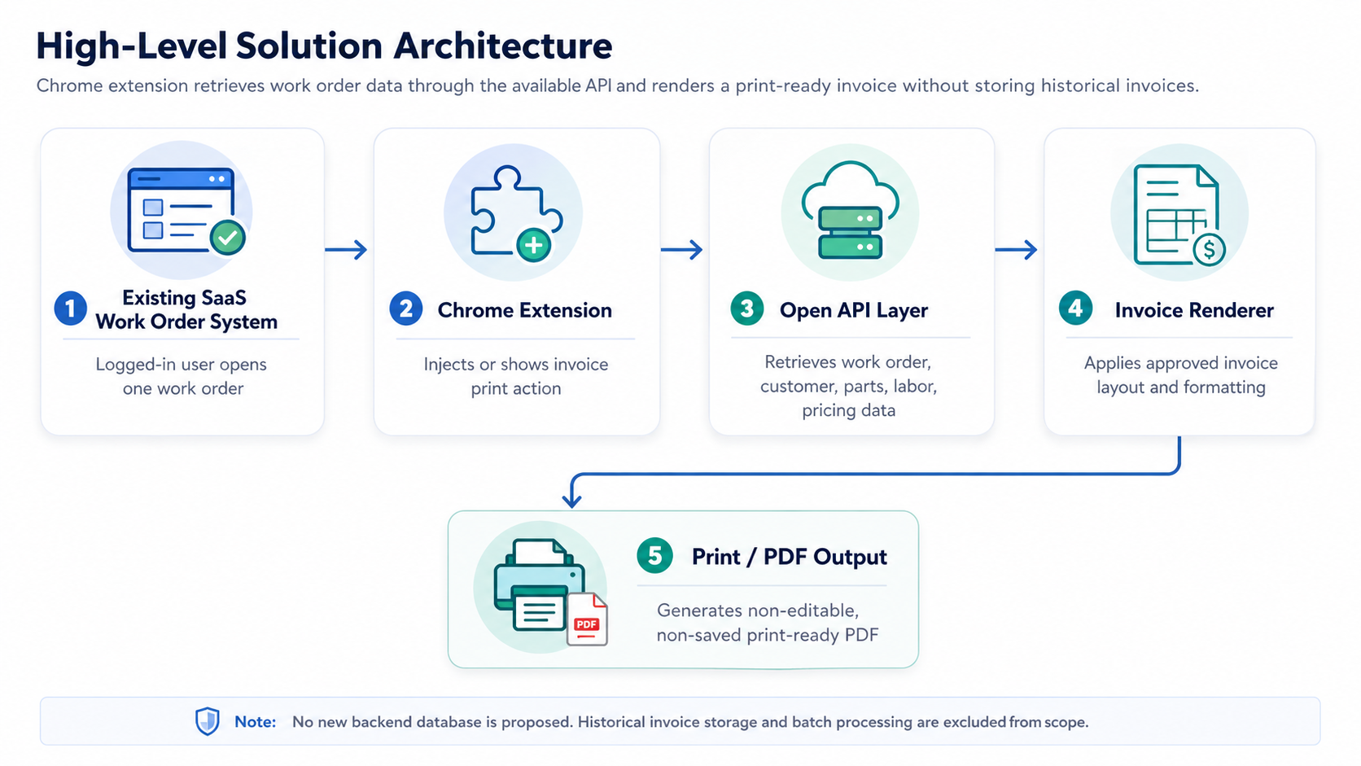
Figure 1: High-Level Solution Architecture

6. Invoice Generation and Print Flow
The workflow is designed to be simple for auto shop staff: open the work order, click the invoice print action, review the generated print view if needed, and print or save as PDF through the browser print dialog.

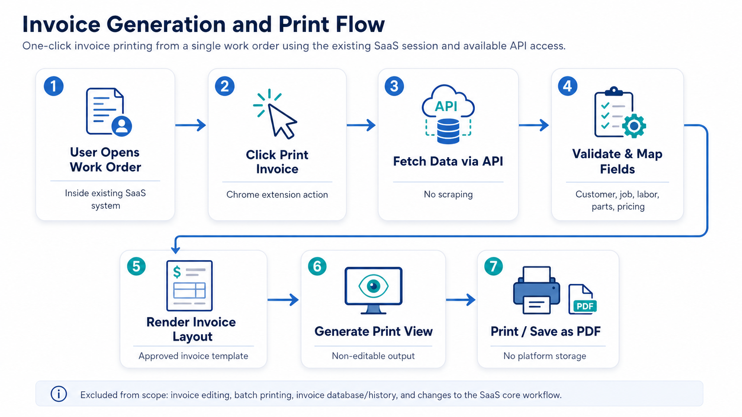
Figure 2: Invoice Generation and Print Flow

7. Proposed Technical Stack
Layer / Area | Proposed Technology | Purpose
Chrome Extension Framework | Google Chrome Extension Manifest V3 | Lightweight and aligned with Chrome-only scope.
Programming Language | JavaScript or TypeScript | Suitable for Chrome extension logic, API calls, and browser-based rendering.
UI Layer | HTML5, CSS3, Print-specific CSS | Used for invoice template layout and browser print/PDF rendering.
API Communication | Fetch API / Axios | Used to call the SaaS open API and retrieve work order data.
PDF / Print Output | Browser Print API / print window; optional PDF library only if required | Keeps the solution simple and avoids server-side PDF generation.
Testing Tools | Chrome DevTools, Postman/Insomnia, manual print testing | Supports API validation, debugging, and output verification.
Version Control | Git | Maintains source control and version history during development.
Packaging | Chrome extension ZIP package / developer mode installation package | Allows controlled installation for the 2 to 3 expected users.

8. Development Methodology
A lean Agile delivery method is recommended because the project scope is focused and the main validation points are API field mapping and invoice layout accuracy. The work can be completed through short iterative checkpoints rather than a large multi-phase delivery model.
Step | Activity | Description
Step 1 | Requirement Validation | Confirm invoice template, required fields, available API endpoints, authentication approach, and target work order page.
Step 2 | Technical Design | Finalize extension architecture, permission model, field mapping, and print rendering approach.
Step 3 | Development | Build extension logic, API integration, invoice layout renderer, and print/PDF trigger.
Step 4 | Internal QA | Validate API responses, invoice layout, Chrome compatibility, error handling, and print/PDF output.
Step 5 | Client Review and Adjustment | Provide a testable build, incorporate agreed refinements, and finalize output.
Step 6 | Handover | Deliver extension package, source code, deployment guidance, and basic user instructions.

9. Indicative Implementation Timeline
Total proposed timeline: 3 weeks

10. Deliverables
No. | Deliverable | Description
1 | Requirement and Field Mapping Summary | List of confirmed invoice fields, API mapping, and key assumptions.
2 | Chrome Extension Build | Installable Chrome extension package for the agreed users/environment.
3 | Custom Invoice Template | Approved print-ready invoice layout implemented in HTML/CSS.
4 | API Integration Logic | Code logic for retrieving and mapping work order data through the available API.
5 | Print / PDF Output Flow | One-click invoice generation and print/PDF workflow.
6 | QA Test Summary | Summary of completed functional, integration, print, compatibility, and regression checks.
7 | Deployment / Installation Guide | Basic steps for installing or enabling the Chrome extension.
8 | User Guide | Simple usage instructions for generating and printing invoices.
9 | Source Code Handover | Source code repository/archive and relevant configuration notes.

11. Testing and Quality Assurance
Testing will focus on correctness, reliability, and print-output quality rather than unnecessary enterprise-level test coverage. The QA process will ensure that the extension performs the confirmed workflow consistently for the target Chrome users.
QA Area | Testing Focus
Functional Testing | Verify that the extension button/action appears in the correct context and generates an invoice from a single work order.
API Integration Testing | Validate successful API calls, response handling, field mapping, and behavior for incomplete or failed responses.
Invoice Layout Testing | Check the invoice against the approved reference layout, including labor, parts, descriptions, totals, dates, and customer/work order information.
Print/PDF Testing | Validate print preview, page breaks, margins, PDF save behavior through the browser print dialog, and non-editable output.
Chrome Compatibility Testing | Test the extension in the latest stable Google Chrome version.
Negative Testing | Check invalid work order page, missing work order ID, expired session, missing fields, and API failure scenarios.
Security and Privacy Review | Confirm minimum permissions, no unnecessary local storage, and no sensitive data logging.
Regression Testing | Retest core flows after fixes or layout adjustments.

12. Acceptance Criteria
- The Chrome extension can be installed and used in the agreed Google Chrome environment.
- The extension can identify or receive the current work order context from the SaaS page.
- The extension retrieves required data through the available API without using web scraping.
- The generated invoice matches the approved professional invoice layout within agreed tolerances.
- The solution generates invoice output for one work order at a time.
- The generated invoice can be printed quickly through the browser print dialog.
- The solution does not provide invoice editing, batch processing, or invoice history/storage.
- User-friendly error messages appear for common invalid or failed scenarios.
- Basic installation and usage instructions are delivered.

13. Assumptions, Dependencies, and Out-of-Scope Controls

13.1 Assumptions
- The SaaS system provides API endpoints that expose all required fields for the invoice layout.
- The client will provide the target invoice layout/reference invoice to be recreated.
- The client will provide API documentation, API credentials/token approach, or access instructions as required.
- The extension will be used only by a small number of authorized users who already have SaaS login access.
- The extension will operate in Google Chrome only.
- The generated invoice does not need to be stored or tracked in a new system.

13.2 Client Dependencies
- Access to a test or demo account in the SaaS work order system, subject to NDA if required.
- Sample work order records with realistic data for testing.
- API documentation and clarification on authentication, rate limits, and required headers.
- Final invoice layout and branding assets, such as logo, address, terms, or other static text if needed.
- Timely feedback on test builds and invoice layout refinements.

13.3 Scope Control Notes
Any requirement outside the confirmed lightweight invoice printing workflow should be treated as a separate change request. This includes backend API development, core SaaS workflow modification, multiple templates, multi-browser support, invoice history, role management, analytics, or accounting/reporting features.

